Name: Rachit Bhatt
Student-ID: C0902810
Group: 2
Subject: CBD (2214) – Big Data Fundamentals and Data Storage Networking

Five V’s of Big Data:
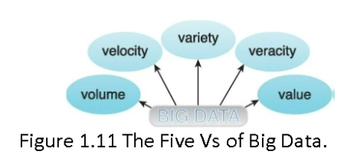
- Volume: The amount of data that is produced and processed by Big Data solutions, which is substantial and ever-growing.
- Velocity: Speed at which the data is being produced and processed.
- Variety: Various formats and types of data that are being generated and processed.
- Veracity: The quality or fidelity of data that is being produced and processed that helps in understanding the signal-of-noise ratio.
- Value: The usefulness (importance) of data produced and processed.

Industry Examples of Big Data Applications:
- Tracking in Transport:
- In transportation, a chip is placed at the place of product which ensures its live tracking.
- This generates a live tracking of that product from being produced till delivered to the customer.
- This does generate a lot of data in each timespan for monitoring the travel map, time analysis, and the overall delivery quality.
- Space Telescopes:
- Various space telescopes constantly monitor the space in order to find something new for the researchers or some natural event such as a meteorite falling, axis of planets, and other space activities.
- This involves various varieties of data such as image, video, or text, and is being constantly generated.
- Banking Transactions:
- Billions of transactions in banks happens in a single day.
- This not only generates a lot of data but also can be used to identify the customer’s behaviour by extracting patterns from a set transaction.

What is LHC?
- Large Hadron Collider is a chemistry organization that deals with atomic and subatomic particles which comes under the consideration of Big Data Analytics.
- It has 150 million sensors delivering data 40 million times per second.
- Nearly 600 million collisions per second happens usually.
- The data flow would exceed 150 million petabytes at an annual rate.
- If all sensor data were to be recorded all-together, the data flow would exceed 150 million petabytes annual rate, or nearly 500 exabytes per day, before replicating it.

What are Big Data Challenges at LHC?
- Addressing how to deal with multi-exabyte data processing.
- Provide an infrastructure to over 6000 scientists from 200 universities and labs in over 45 countries around the world.
- Analyse the data in search of new discoveries, which, at times, enforces GRID distributed computing.
- Storing such a huge set of data is another challenge since hardware wares out easily.
- Network bandwidth is another query to be resolved while transmitting such an amount of data across world.

What will the Large Hadron Collider reveal?
- Helps in discovering the unknown particles present in various elements.
- Understand space and time.
- Helps in understanding the microstructure of matter and the laws of nature.
- Gives clarity in how the chemicals reacts in the nano world (quantum world).

